**Object Oriented Analysis and Design**

***Name:*** Jagadeesh Raj

***Register No:*** 192011101

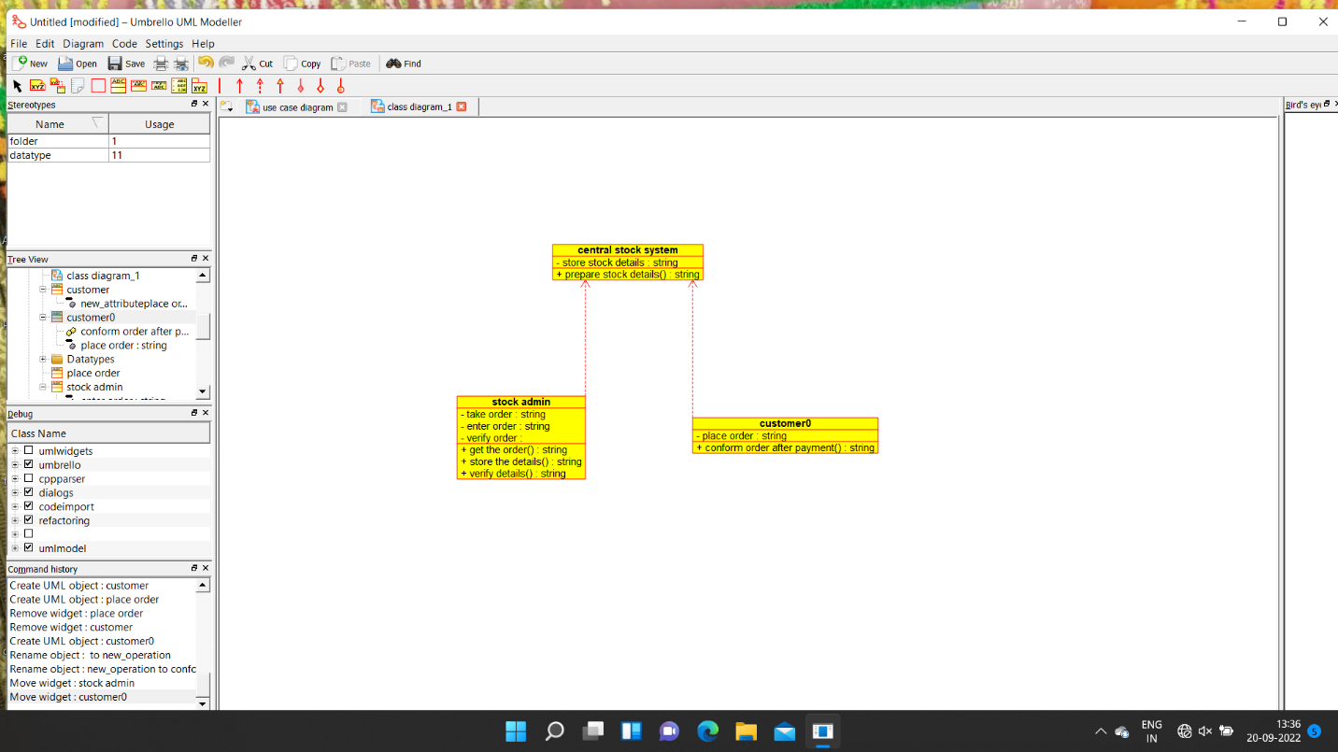

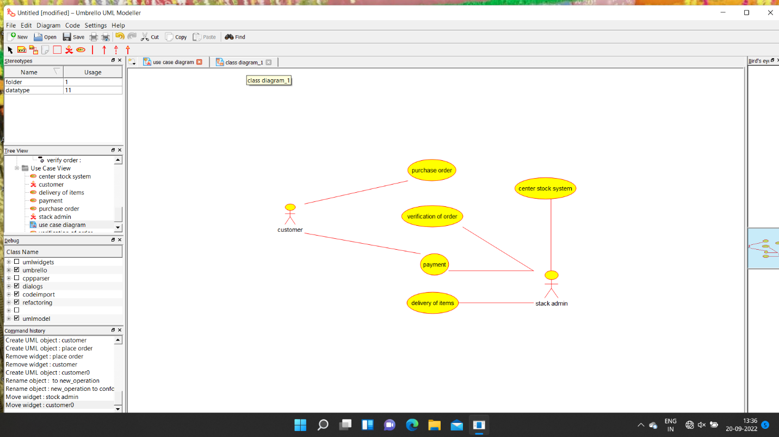

/**

* Class central_stock_system

*/

public class central_stock_system {

//

// Fields

//

private String store_stock_details;

//

// Constructors

//

public central_stock_system () { };

//

// Methods

//

//

// Accessor methods

//

/**

* Set the value of store_stock_details

* @param newVar the new value of store_stock_details

*/

private void setStore_stock_details (String newVar) {

store_stock_details = newVar;

}

/**

* Get the value of store_stock_details

* @return the value of store_stock_details

*/

private String getStore_stock_details () {

return store_stock_details;

}

//

// Other methods

//

/**

* @return String

*/

public String prepare_stock_details()

{

}

}

/**

* Class customer

*/

public class customer {

//

// Fields

//

private void new_attributeplace_order;

//

// Constructors

//

public customer () { };

//

// Methods

//

//

// Accessor methods

//

/**

* Set the value of new_attributeplace_order

* @param newVar the new value of new_attributeplace_order

*/

private void setNew_attributeplace_order (void newVar) {

new_attributeplace_order = newVar;

}

/**

* Get the value of new_attributeplace_order

* @return the value of new_attributeplace_order

*/

private void getNew_attributeplace_order () {

return new_attributeplace_order;

}

//

// Other methods

//

}

/**

* Class place_order

*/

public class place_order {

//

// Fields

//

//

// Constructors

//

public place_order () { };

//

// Methods

//

//

// Accessor methods

//

//

// Other methods